Python Bytes Take Home Sheet 5
Some fun coding exercises for you to do! No stress! If you have any questions, feel free to mark them up and ask.

Activity 1: What will the following code do? Predict first, then run the code to test your predictions. You can use scratch paper! Note: the quotation marks get messed up if you copy paste into VSCode, so change those in VS after copying.

# | Question | Output | Reason
1. | 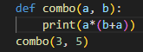 | 24 | When we call combo(3, 5) we are passing arguments 3 and 5 as a and b. Thus, the program prints out 3*(3+5) = 3*8 = 24
2. | 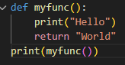 | Hello  World | When we call myfunc(), we print out “Hello”. After that, myfunc() returns a value which we then print. Thus, “Hello” and “World” are both printed.
3. | 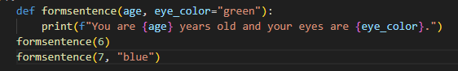 | You are 6 years old and your eyes are green.  You are 7 years old and your eyes are blue. | Eye_color is a default parameter, so it defaults to “green” here even though it is not called.  The second calling of the function has two positional arguments (they are in order of the parameters). Thus, age = 7 and eye_color = “blue”.
4. | 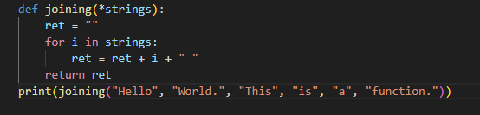 | Hello World. This is a function. | *strings is an arbitrary argument parameter and thus is treated as a list. Thus, all the arguments we pass are put into the list.
5. | 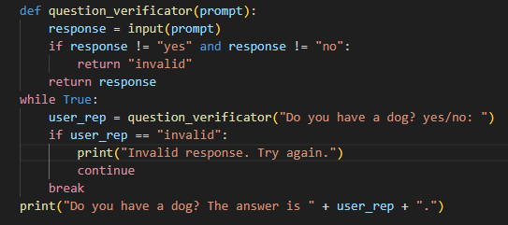 | #This code will ask if the user has a dog. If the user says yes or no, the print statement is printed. Otherwise, it says Invalid response. Try again. And it repeats. | When user_rep isn’t “invalid” (response is either “yes” or “no”), then the while loop breaks. Otherwise, the while loop repeats again and the question is asked again.

Activity 2: Predict what the following code will do, then run it! This one is not required. It is difficult, but if you think hard enough, the following code will start to make sense. Feel free to search this up!
- Let’s analyze this line by line.
The first thing that is called is print(target(0, 200)) so we attempt to find the value of target(0, 200).
In target(0, 200), current is less than final so we return target(bankreturns(0), 200). Running bankreturns(0) gives us 6. So, we find target(6, 200).
Repeat the process to get
target(6, 200) = target(24, 200) = target(78, 200) = target(240, 200)
Now, when we run this, current > final so target(240, 200) = 40.
So, the code will print out 40.
—------------------------------
This code basically tells us, if we get 2 dollars at the start of each day and it triples at the end of each day, how much extra money will we have after we buy a 200$ item when we have enough money to buy it?
- When we run closure(rows, row_length), we define another function inside with a default parameter. Then, we return this function. So, let us think of the first line run print3by3 = closure(3, 3).
closure(3, 3) returns a function that adds the item parameter with default “” row_length times for row times. Basically, it creates a row * row_length 2d array with the item being in each element. When we run print3by3(), we thus get:
[[‘’, ‘’, ‘’], [‘’, ‘’, ‘’], [‘’, ‘’, ‘’]]
which is a 3 by 3 2d array with all the items being ‘’.
print4by3 is similar, created from closure(4, 3). When we run print4by3(‘O’), we get a 4 by 3 2d array, but we do pass an argument ‘O’ so each item in the 2d array is ‘O’. Thus, it prints
[[‘O’, ‘O’, ‘O’], [‘O’, ‘O’, ‘O’], [‘O’, ‘O’, ‘O’], [‘O’, ‘O’, ‘O’]]

Activity 3: Word Problem
The correct answer is that the hackers started hacking at 4:54 AM.
Your code should look something similar to this. (on next page).
